**ST. JOSEPH’S TRAINING COLLEGE, PAVARATTY**

**GRIEVANCE REDRESSAL CELL**

**AWARENESS PROGRAM REPORT 2023-24**

The Grievance Redressal Cell at St. Joseph's Training College, Pavaratty, is chaired by the Principal and includes one coordinator and two senior faculty members dedicated to resolving B.Ed students' complaints. Students can report their grievances regarding any academic or non-academic issues within the campus through an online system or by dropping complaints in a designated grievance box.

On 17th August 2023, the Cell conducted an awareness program to the students of 2023-25 batch to communicate the guidelines for addressing student grievances. This program, led by Mrs. Soumya V. S., the Coordinator of the Grievance Redressal Cell, was aimed at both teachers and student-teachers to familiarize them with the Cell's rules and regulations. The awareness initiative significantly contributed to maintaining a harmonious and supportive environment for all academic and non-academic activities.

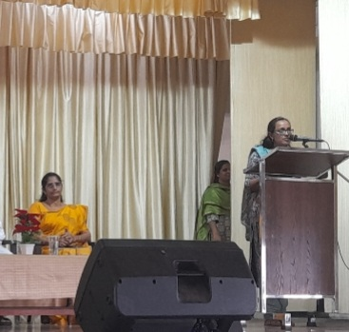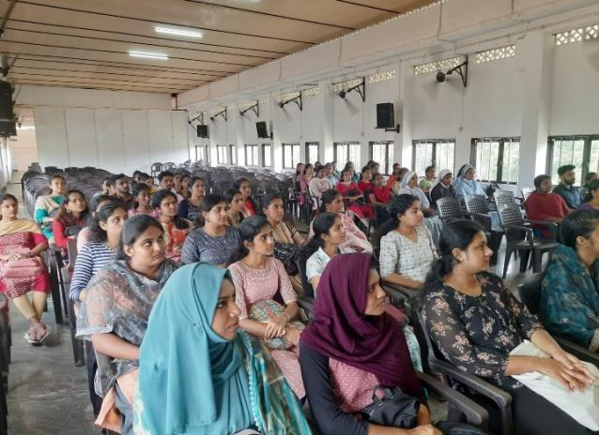

**ST. JOSEPH’S TRAINING COLLEGE, PAVARATTY**

**GRIEVANCE REDRESSAL CELL**

**AWARENESS PROGRAM REPORT 2024-25**

On 23rd August 2024, the Grievance Redressal Cell organized an awareness program for the students of 2024-26 batch. The session, led by Mrs. Shimy C.V., the Coordinator of the Grievance Redressal Cell, was designed to inform both the teachers and student-teachers about the procedures for addressing student concerns and grievances. During the program, Mrs. Soumya outlined the guidelines and regulations that govern the Cell’s operations, ensuring that everyone involved was well-versed in how to approach and resolve issues. This initiative played a crucial role in fostering a positive, collaborative atmosphere, benefiting both academic and non-academic activities within the institution.

